Lillian and The Best of Dorien B.
Now playing on YourScreen Virtual Cinema until Sun 06 Dec
YourScreen is pleased to announce that by popular demand, we have extended the run of two of this season’s titles on our virtual cinema platform.
Lillian and The Best of Dorien B. will remain available on our platform until Sunday 06 December, so you have nearly two more weeks to promote them to your audience.

Lillian has had fantastic feedback from our Virtual Screening Partners, praising its visual poetry, enigmatic central performance and wry commentary on the attitudes and mores of small-town America, given added resonance as the fallout from the US election continues.

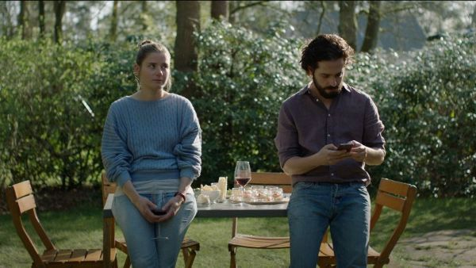
The Best of Dorien B. is the most popular film off the season, a breezy comedy drama marked by a tremendous lead performance by Kim Snauwaert in only her second film role. Backed by a witty and perceptive script, a Dorien wonderfully engaging character that you will find yourself routing for as she copes with everything life throws at her.
There are plenty of other films to promote to your audiences in the coming weeks, including Innuit drama Kuessipan, which many partners have chosen as their Christmas offering.
If you haven’t come on board with YourScreen yet, please take a look at our website to see how you can receive a 30% revenue share from tickets sold to your audience, or if you are a film society, organise a group screening for your members. https://yourscreen.net/

