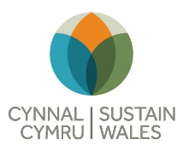
Film Hub Wales
Climate Change Adaptation Risk Planning Tool – from Cynnal Cymru
Type your own analysis into the boxes during the session on the 29th
Potential Scenario | Possible Impacts | Risk Management Response(s) | Risk Severity Score(s) (high medium low)
Heavy rain – surface water flooding
Heavy rain – river floods
Storms – wind damage
Storms – tidal surge
Extreme heat days
Prolonged drought
Ice and snow
International or regional impacts
?

